**CIT349**

**Winter 2017**

**Lab 2: Docker / Windows Server 2016 / Ubuntu 18.04 Installation**

**Due date: February 1st @ 11:55pm**

**Synopsis:**

This lab will have you learning about Docker, and will also finish up some more installs (Windows Server 2016 and Ubuntu 18.04 on the school VMs). The actual homework questions will be posted separately.

**Steps:**

**0) Ensure that you can access your virtual machine.**

You will need access to the school’s VPN in order to connect to vcenter. Ensure that you’ve installed the appropriate tools from CTO (https://oakland.edu/secs/student-resources/).

VPN: <http://secs.oakland.edu/docs/pdf/vpn.pdf>

VPN (Windows 10): <http://www.secs.oakland.edu/docs/pdf/win10Vpn.pdf>

Login to vcenter with your SECS username and password: <https://vcenter.secs.oakland.edu/>

Sadly, you still have to choose the Flash option. HTML5 support is still not there yet (VMWare's fault, according to many, many Reddit rants against vsphere).

**1) Login to your virtual machine via vcenter and update the administrator password**

You should have **two** VMs in your account. You should have to click this tab (VM) to see them:

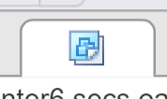

One will be named <your username>, the other will be <your username>-Windows. You're going to install Ubuntu 18 on the first, and Windows Server 2016 on the second. Let's start with Windows.

The Windows Server 2016 disc is pre-loaded for you, but you have to install it yourself.

One thing you may notice (if you are unlucky, like me) is that your mouse cursor doesn’t work. This means that we're going to be stuck using the keyboard. So, get used to using the Tab and Enter keys.

When you get to the Product Key screen, tab over until you get to 'I don't have a product key' and select that. We'll have a small watermark on the screen telling us to register Windows, but it will be fine.

Now I'll just list out specific options you need to pick as you go.

* Pick **Windows Server 2016 Datacenter (Desktop Experience)**
* Select **Custom: Install Windows Only**

Let it install. This may take a little bit of time. While you're waiting, think about your term project. Maybe what you're going to have for dinner. No think about your term project and what needs to be done for that. Should you maybe start looking up what tools need to be installed? Oops the install is done back to the lab.

Time to create an Administrator password. Make sure you remember it, as nobody but you and I will have access to these machines. Note you will need at least one letter to be capitalized. After that, login!

**VMWare Tools**

This step is important, as it will give mouse access. Go back to vcenter, right click on your VM, and select Guest OS 🡪 Install VMWare Tools.

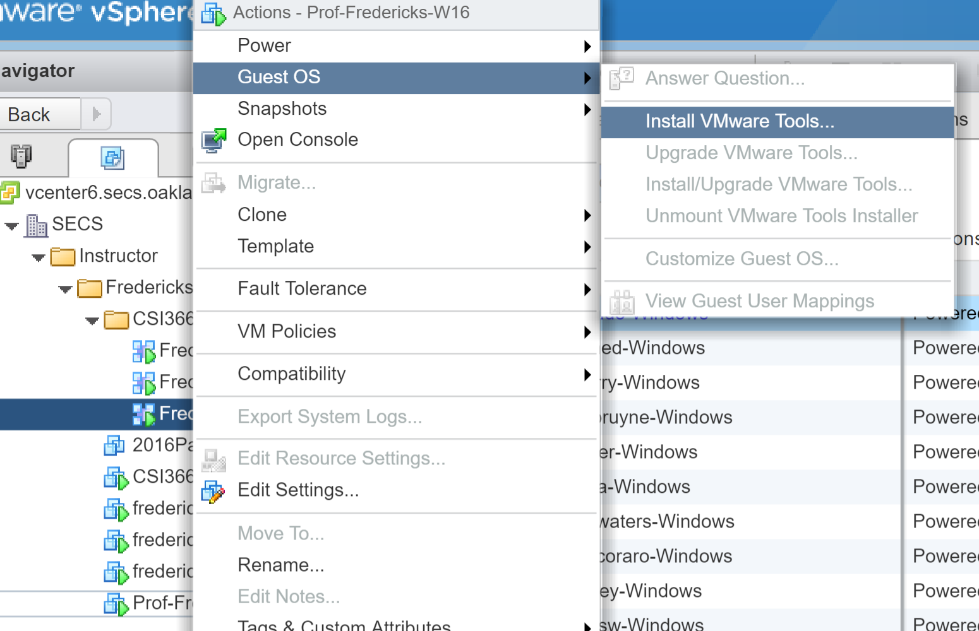

(Click Mount when it pops up). This will load the tools to the CD of the server, so you'll still need to install it. Open the Start Menu and launch PowerShell (this might be the Command key if you're on MacOS). You might get 2 start menus popping up, alt+tab to give the browser the focus so you can work with Windows. Type powershell to launch a powershell terminal.

Then:

cd D:\

.\setup64.exe

If you lose tab focus, type 'exit' in PowerShell. VMWare Tools should be front and center. Select 'Typical' for VMWare tools and let it install, and then allow it to reboot the machine.

You should now have mouse support! See how important VMWare Tools are?

For now, we are just going to leave it as is. Once we get our domain setup, accounts for myself and the TA will be automagically created.

Last thing. Rename your PC to something more related to you. Search for 'This PC.' Then right click on This PC and select Properties. Next to the Computer Name item select 'Change Settings.' Then click 'Change' again. Change the computer name to whatever your last name is.

**Ubuntu**

Open up your other VM.

Ubuntu’s installer should load Follow along with the install process. When you get here, check to **Download updates while installing** and **Install this third-party software**.

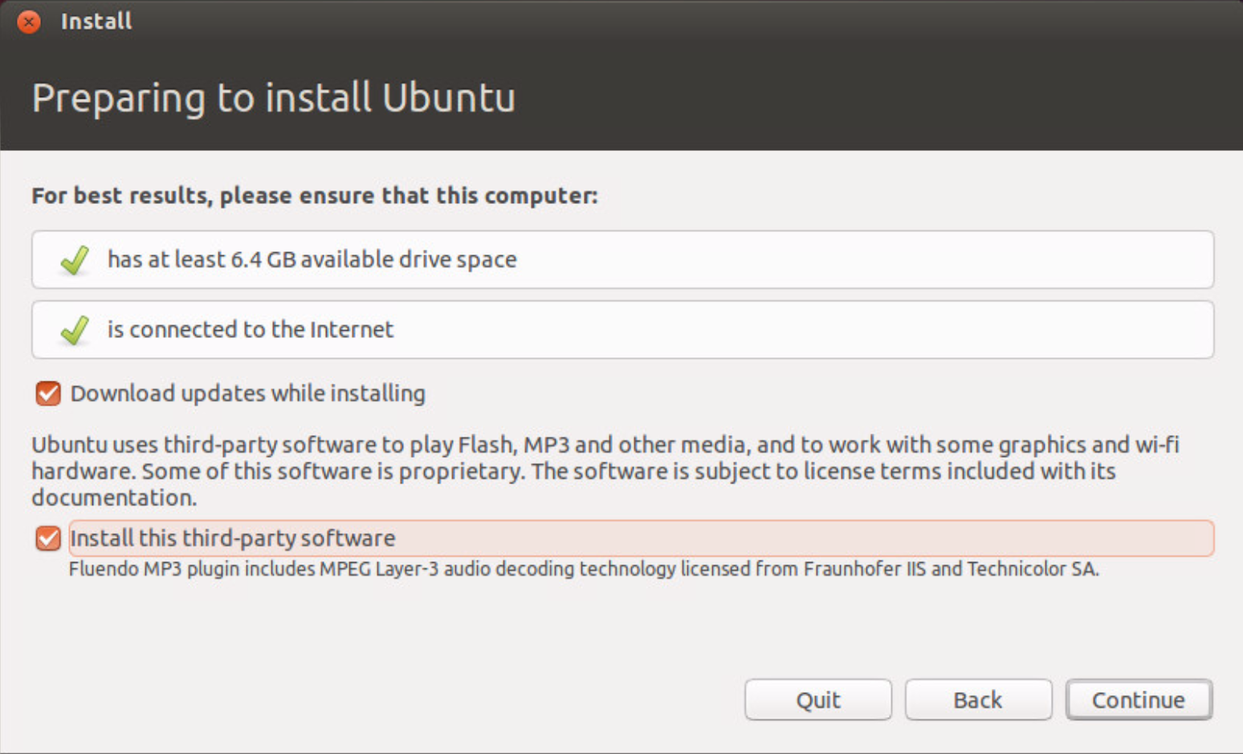

Set your timezone, keyboard layout, etc., until you get to the **Who are You** screen. **This username and password will be how you login to your Ubuntu partition!**

Installation should run smoothly now. Reboot.

Load up Ubuntu. Open up a terminal and run:

**$ sudo apt-get update && sudo apt-get upgrade**

Set your root password. In a terminal, type **sudo passwd** to set your super user’spassword**.**

Create a user account for myself and the TA, and give us sudo access. The password should be **temp12345** for both of us.

**$ sudo adduser fredericks**

**$ sudo adduser ma**

**$ sudo usermod -aG sudo fredericks**

**$ sudo usermod -aG sudo ma**

5.5) Fourth, enable the SSH service:

**$ sudo apt-get update**

**$ sudo apt-get upgrade**

**$ sudo apt-get install openssh-server**

**$ sudo ufw allow 22**

That’s it for now! On to the homework!